**Mobile Application Development Lab**

**(ITPC-326)**

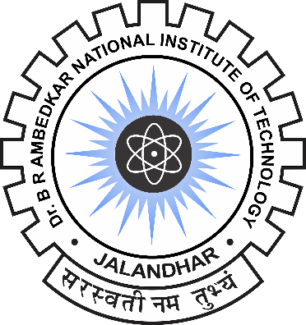

**Dr. B R Ambedkar National Institute of Technology, Jalandhar**

**Punjab- 144011**

**SUBMITTED TO : SUBMITTED BY :**

Dr. Deepak Garg Arvinder Sngh

Dept. Of Information Technology 18124004

IT/6th Semester